EasyFin

Travis Pratt

CS449

Vision Statement for EasyFin

For all those people who have trouble keeping track of their finances EasyFin is the answer. Unlike other apps this app is an all-in-one app that combines financial planning, easy stock checks, and ease of mind. This app will add the functionality of alerts that tell you when payments are due as well as make sure you don’t overspend on your budget. This product is different since it keeps all of your private information local. None of those pesky corporations getting in on your financial status and sending you junk mail.

Actor Goal

|  |  |
| --- | --- |
| **ACTOR** | **GOAL** |
| User | Check stocks using identifier |
|  | Taps Stocks tab |
|  | Types in Stock identifier in field |
|  | Return stock info |
| User | Check stocks using saved identifier |
|  | Selects desired identifier |
|  | Clicks ok |
|  | Returns stock info |
| User | Wants to add bill amount to log |
|  | Clicks on bills tab |
|  | Clicks add bill |
|  | adds information about bill |
|  | Clicks save bill |
|  | Adds bill to log |
| User | Wants a chart about spending |
|  | Clicks bills tab |
|  | Clicks show chart |
|  | Clicks desired chart |
|  | Shows chart of spending habits |
| User | Wants to change how much of their paycheck they want to put in savings. |
|  | Clicks on bills |
|  | Clicks on adjust savings |
|  | Inputs new percentage or flat rate |
|  | Logs update to change savings amount |
|  |  |
|  |  |

Product Backlog

|  |  |  |  |  |
| --- | --- | --- | --- | --- |
| Story ID | Story | Story points | Priority | Status |
| S1 | Allow user to check stocks by identifier | 35 | 1 | 10/2/17 CMP |
| S2 | Allow user to check stocks by saved identifiers | 3 | 2 | 10/2/17 CMP |
| S3 | Allow user to save bill amounts in local storage | 5 | 1 | 10/8/17 CMP |
| S4 | Notify user when bill is due | 32 | 2 | 11/05/17 CMP |
| S5 | Allow user to view bills and days due | 19 | 1 | 11/05/17 CMP |
| S6 | Allow user to access a pie chart that shows spending habits defined as bills/savings/available | 5 | 3 | 11/22/17 CMP |
| S7 | Allow user to see a line graph on how much they spent per month basis | 5 | 3 | 11/22/17 CMP |
| S8 | Allow user to set how much they want to set aside for savings every month | 5 | 3 | 11/22/17 CMP |
| S9 | Connect to Cryptocompares database | 5 | 1 | 9/24/17 CMP |
| S10 | Allow user to delete a bill from the table | 5 | 4 |  |
| S11 | Refactor access functions for shared preferences | 8 | 5 |  |
| S12 | Make the UI more user friendly | 8 | 5 |  |
| S13 |  |  |  |  |

Sprint 1 plan

|  |  |  |  |
| --- | --- | --- | --- |
| **Story ID** | **Story / Task** | **Estimated**  **Hours** | **Actual**  **Hours** |
| S1 | Allow user to check stocks by identifier |  |  |
|  | Design UI | 3 | 3 |
|  | Create SharedPreferences | 2 | 2 |
|  | Find and implement API for getting stocks | 7 | 30 |
| S3 | Allow user to save bill amounts in local database |  |  |
|  | Set up shared preference | 2 |  |
|  | Design UI | 3 |  |
| S5 | Allow user to view bills and days due |  |  |
|  | Design UI | 3 |  |
|  | Attach table to data in shared preference | 5 |  |
|  | Add search option | 4 |  |

Sprint 2 plan

|  |  |  |  |
| --- | --- | --- | --- |
| **Story ID** | **Story / Task** | **Estimated**  **Hours** | **Actual**  **Hours** |
| S1 | Allow user to check stocks by identifier |  |  |
|  | Design UI | 3 | 3 |
|  | Create SharedPreferences | 2 | 7 |
|  | Find and implement API for getting stocks | 7 | 50 |
| S3 | Allow user to save bill amounts in local database |  |  |
|  | Set up shared preference | 2 |  |
|  | Design UI | 3 |  |
| S5 | Allow user to view bills and days due |  |  |
|  | Design UI | 3 |  |
|  | Attach table to data in shared preference | 5 |  |
|  | Add search option | 4 |  |

Sprint 3 plan

|  |  |  |  |
| --- | --- | --- | --- |
| **Story ID** | **Story / Task** | **Estimated**  **Hours** | **Actual**  **Hours** |
| S3 | Allow user to save bill amounts in local database |  |  |
|  | Set up shared preference | 2 | 3 |
|  | Design UI | 3 | 8 |
| S4 | Notify users when bill is due |  |  |
|  | Set up notifications | 5 |  |
|  | Allow for app to send notifications even when app is off | 5 |  |
| S5 | Allow user to view bills and days due |  |  |
|  | Design UI | 3 | 3 |
|  | Attach table to data in shared preference | 5 | 12 |
|  | Add search option | 4 |  |

Sprint Velocity:5

Sprint Review

Overall the sprint went well ran into a speed bump when I had to refactor the way the bills were stored to allow them to fit in the sharedPreferences. I haven’t made the search option yet because I am still not sure how I want to search each function whether that being by name or date or amount or all 3. The next sprint I should be able to figure out which avenue I want to go with.

Sprint Retrospective

What I could of done better is seeing that using a table instead of a linearlayout with textviews would be a better approach since using the table method allows you format the way the text is handled by allowing equal spacing. This allows the labels to line up correctly on any size device without using spaces. Tables also auto size the text of the rows which is useful in longer strings of texts.

Sprint 4 plan

|  |  |  |  |
| --- | --- | --- | --- |
| **Story ID** | **Story / Task** | **Estimated**  **Hours** | **Actual**  **Hours** |
| S4 | Notify users when bill is due |  |  |
|  | Set up notifications | 20 | 20 |
|  | Allow for app to send notifications even when app is off | 12 | 12 |
| S5 | Allow user to view bills and days due |  |  |
|  | Design UI | 3 | 3 |
|  | Attach table to data in shared preference | 5 | 12 |
|  | Add search option | 4 | 4 |

Sprint Velocity:20

Sprint Review

The Sprint took longer than expected since I ran into some speed bumps when developing the notifications. Now all that needs to be done is getting functionality on the delete button which should be a formiddable task.

Sprint Retrospective

Wish the documentation of how Notifications and Notification broadcasts were written better it made it extremely hard to figure out how to implement them into my code. After I finished though I feel that I could do it again with greater understanding. I learned a lot about how android does its timers for its notifications and it seems like a complicated way of doing it.

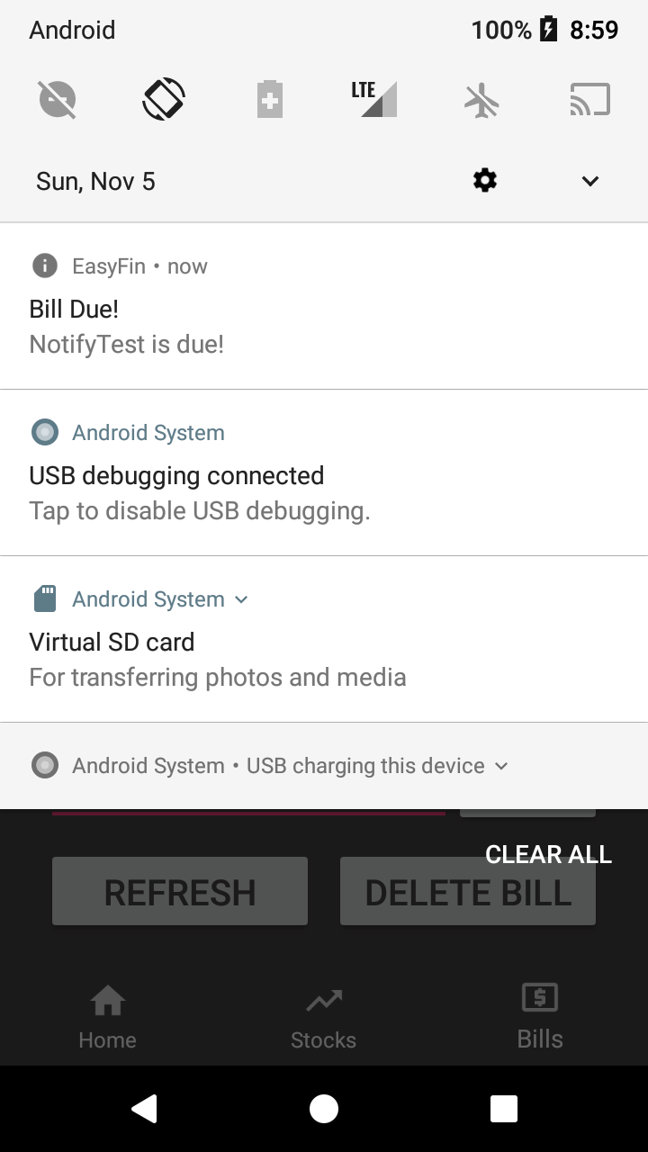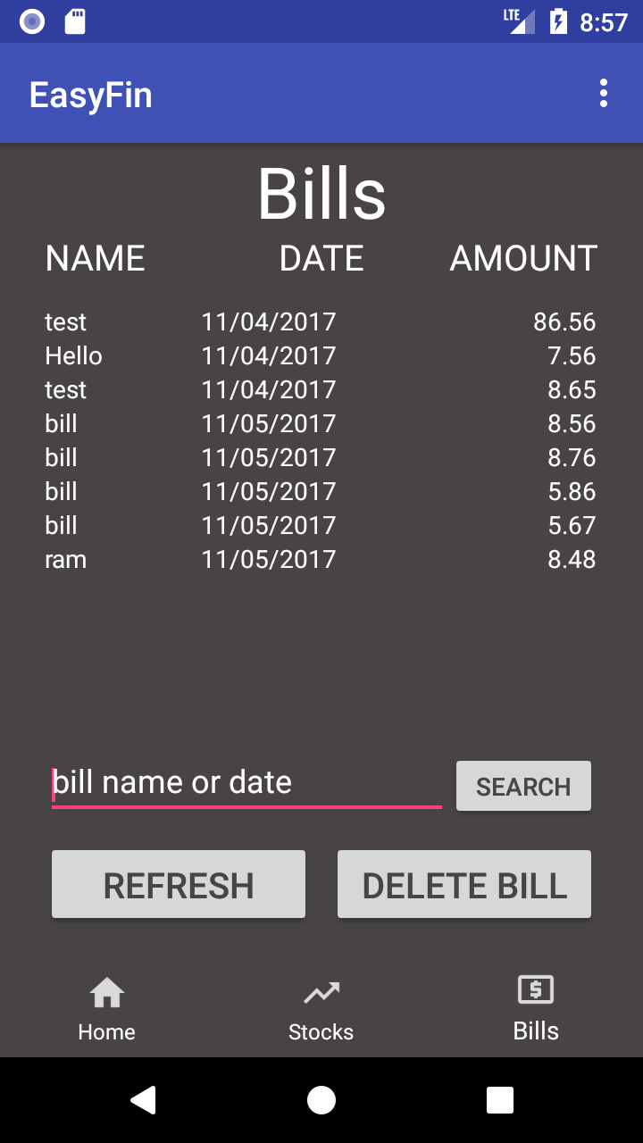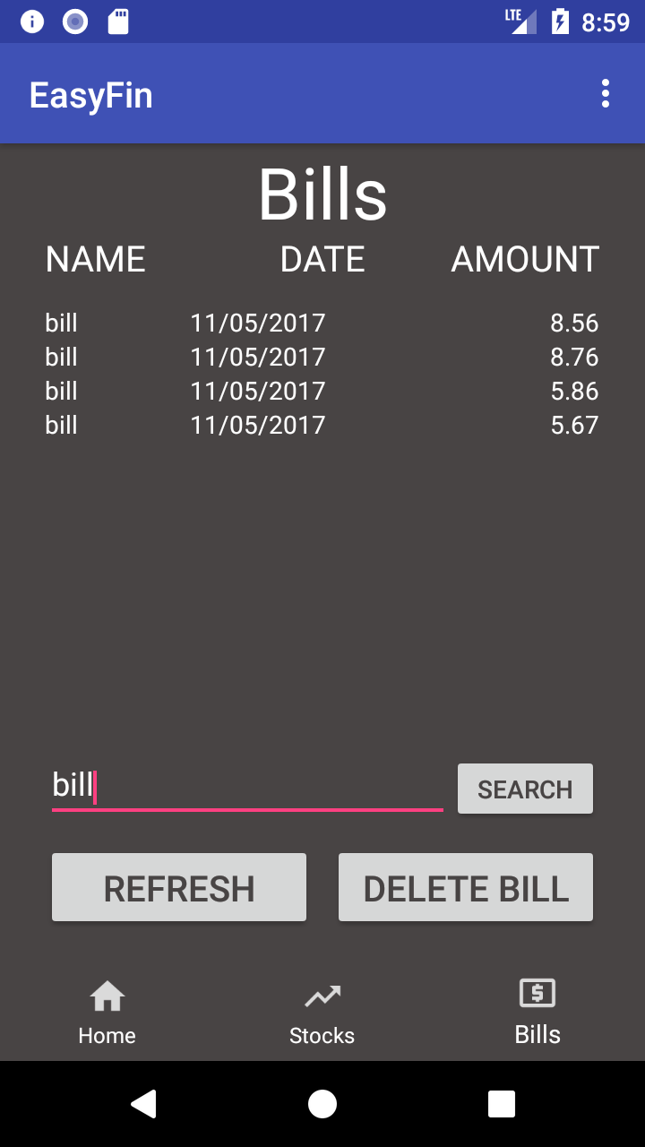

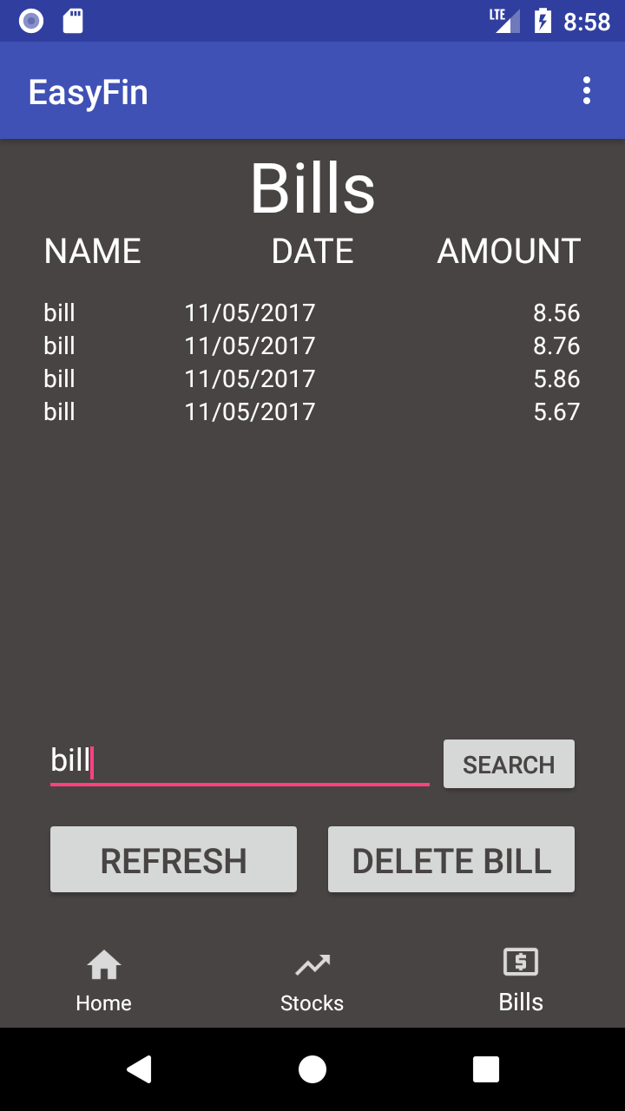

Sprint 5 Plan

|  |  |  |  |
| --- | --- | --- | --- |
| **Story ID** | **Story / Task** | **Estimated**  **Hours** | **Actual**  **Hours** |
| S7 | Allow user to see a line graph on how much they spent per month basis |  |  |
|  | Find and implement the API that allows drawing of line graphs | 20 | 25 |
|  | Give the user the choice multiple months | 12 | 12 |
| S8 | Allow user to set how much they want to set aside for savings every month |  |  |
|  | Design UI | 3 | 3 |
|  | Hook up savings amount to a sharedpreference | 3 | 3 |
|  | Add this amount to the monthly expense | 12 | 12 |

Sprint Velocity: 20

Sprint Review

This sprint was proabably the smoothest out of all of them the only hiccup I had was finding a pie graph module for the app.

Spring Retrospective

Overall I don’t think there was anything I could’ve done better since the sprint went so smoothly. Im getting better at estimating time the only one that took longer was implementing the apis of other people which can sometimes be a pain.

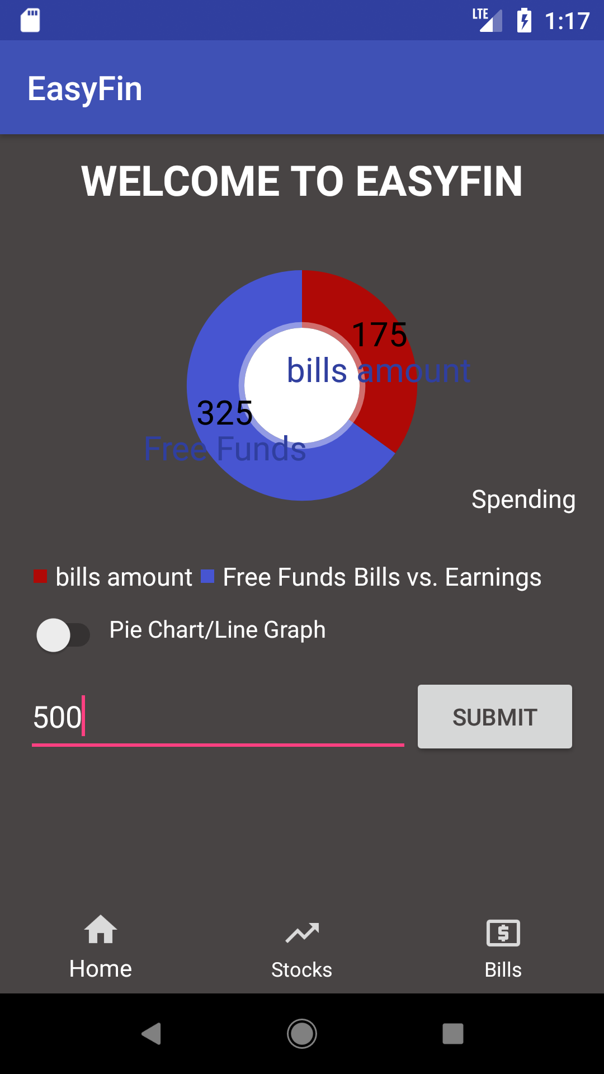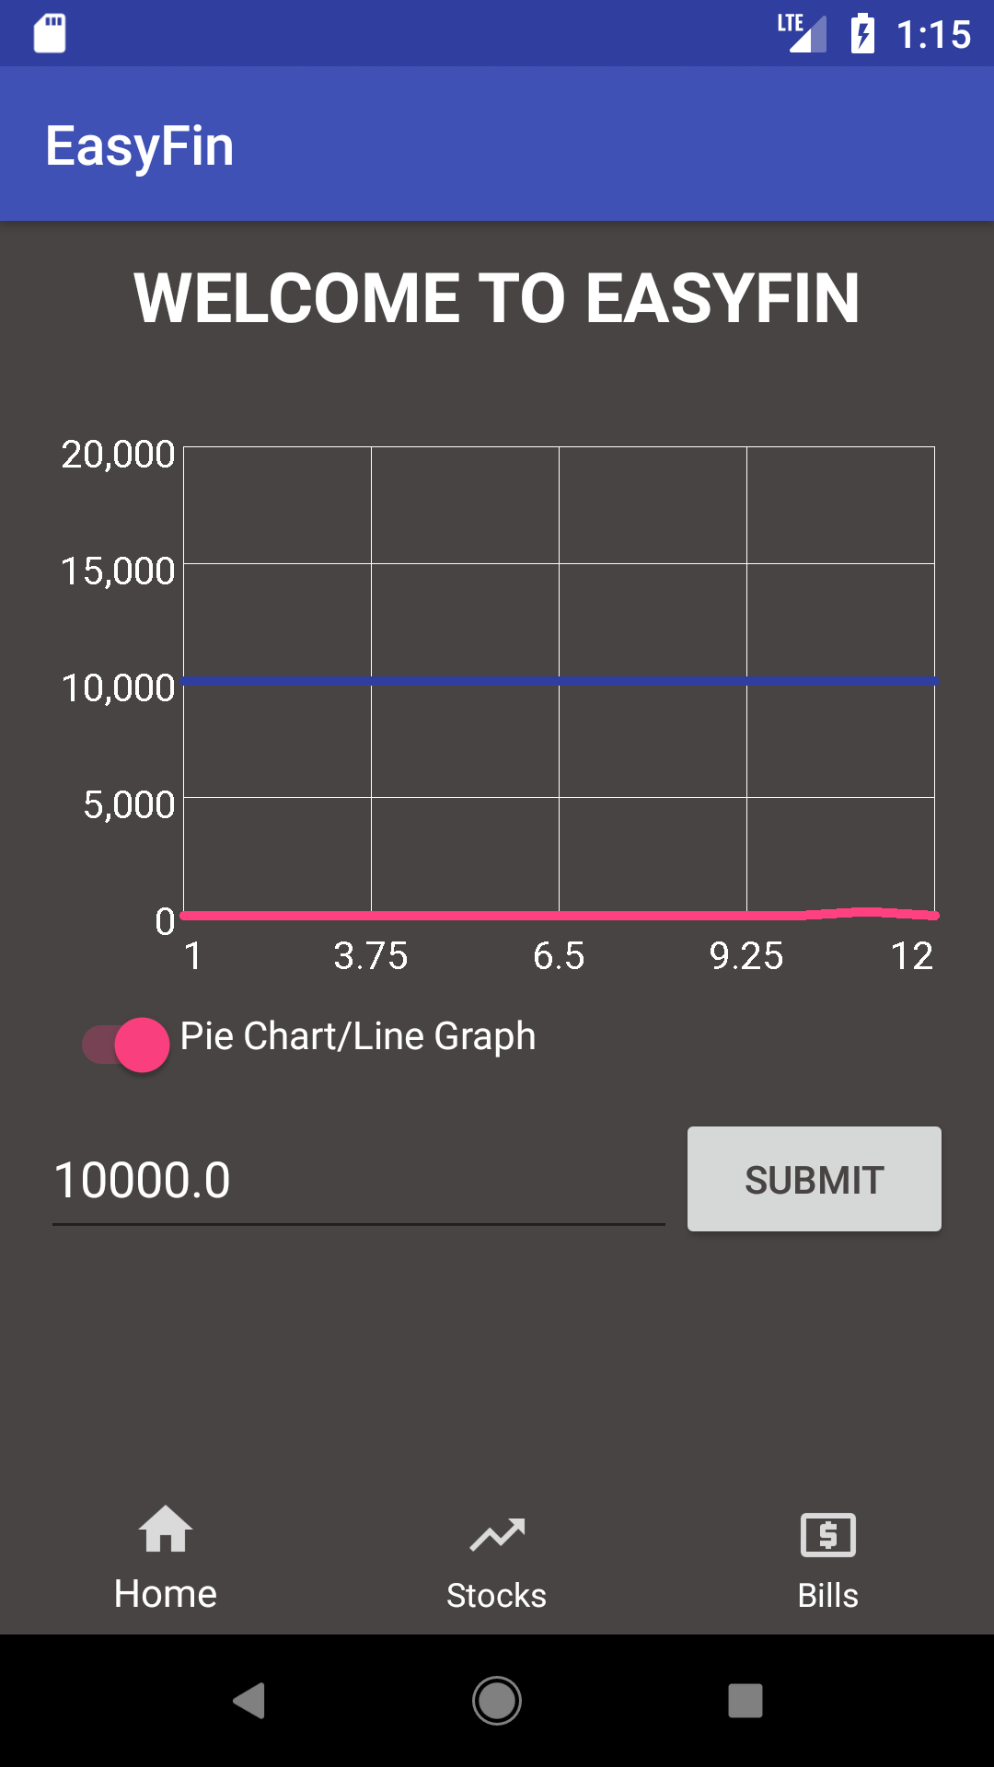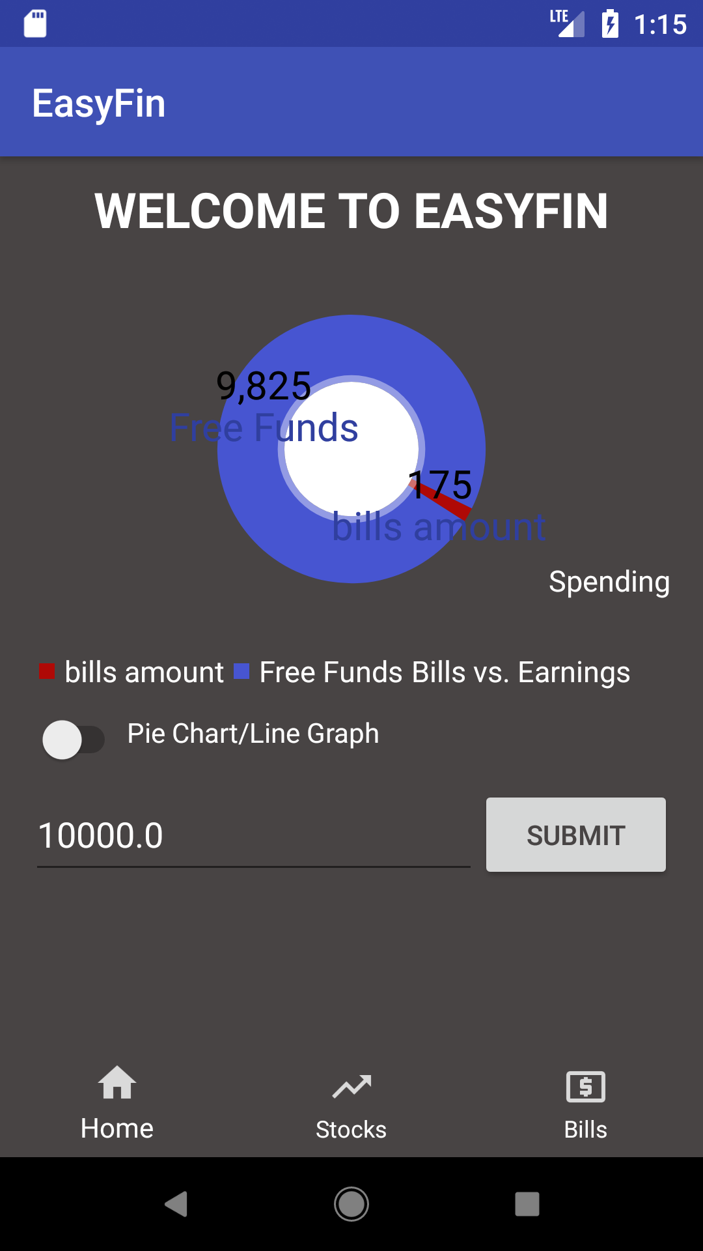

Sprint 6 Plan

|  |  |  |  |
| --- | --- | --- | --- |
| **Story ID** | **Story / Task** | **Estimated**  **Hours** | **Actual**  **Hours** |
| S10 | Delete bill from table |  |  |
|  | Create delete bill function | 8 |  |
|  | Attach button to function | 1 |  |
| S11 | Refactor access functions for shared preferences |  |  |
|  | Better sorting algorithm? | 6 |  |
|  | Make the shared preference class look better | 12 |  |
| S12 | Make the UI more user friendly |  |  |
|  | Tweak the colors to make it more easier on the eyes | 6 |  |
|  | Change some things around to make them more visible like the action bar | 8 |  |

Sprint Velocity: 12